Bahria University,

Karachi Campus



LAB EXPERIMENT NO.

**8**

LIST OF TASKS

|  |  |
| --- | --- |
| TASK NO | OBJECTIVE |
| 1 | Write a program in MIPS assembly language that takes input and display whether number is prime or not. |
| 2 | Take input from user and find its Factorial by using loop. |
| 3 | Adding all numbers from 1 to 10 number using loop. |
| 4 | Write a program in MIPS assembly language that provide the sum from 1 to 99 using for Loop. |
|  |  |
|  |  |
|  |  |
|  |  |

Submitted On:

Date: 29/12/2021

**Task 1: Write a program in MIPS assembly language that takes input and display whether number is prime or not.**

**Solution :**

.data

input: .asciiz "Enter any number = "

notPrime: .asciiz "This number is not prime number"

prime: .asciiz "This is Prime Number"

.text

.globl main

main:

li $s0,2 #s0 ==> i

la $a0,input

li $v0,4

syscall

li $v0,5

syscall

move $t0,$v0 #t0 user input(n)

blt $t0,$s0,notprime

div $t0,$s0

mflo $t1 #t1 ==> loop n/2

b condition

condition:

ble $s0,$t1,enterLoop

la $a0,prime # this prime number

li $v0,4

syscall

b exit

enterLoop:

div $t0,$s0 #n/i

mfhi $t2 #t2 ==> 0 or 1

beqz $t2,notprime

addi $s0,$s0,1

b condition

notprime:

la $a0,notPrime

li $v0,4

syscall

b exit

exit:

li $v0,10

syscall

**Output :**

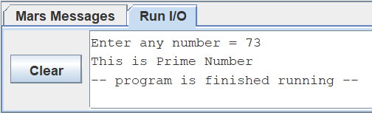

.

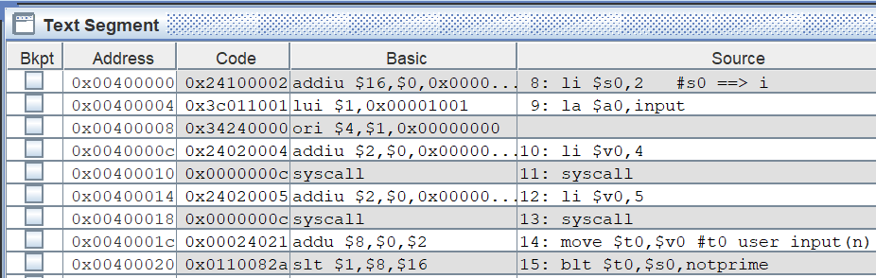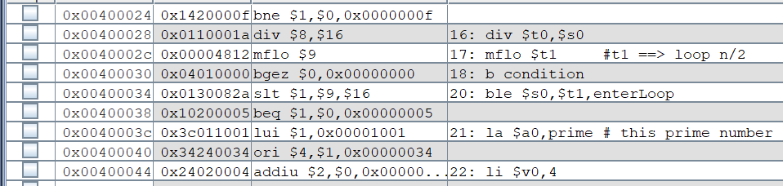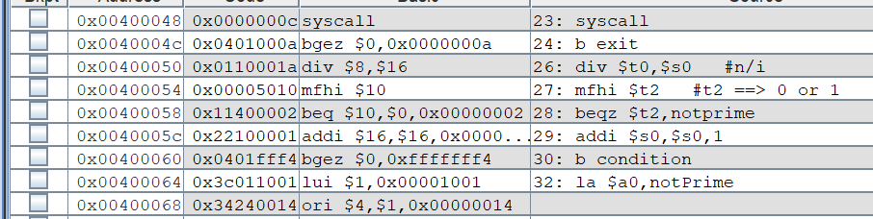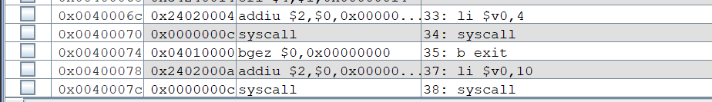

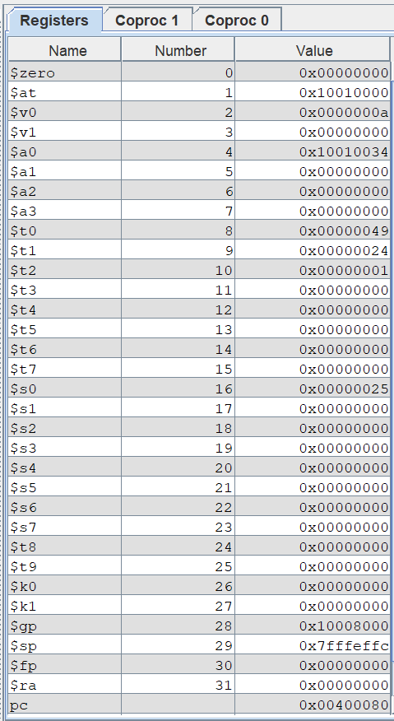

**Task 2: Take input from user and find its Factorial by using loop.**

**Solution :**

. data

input: .asciiz "Enter any number = "

fact: .asciiz "Factorial is = "

.text

.globl main

main:

li $s1,1 # fact variable

la $a0,input

li $v0,4

syscall

li $v0,5

li $v0,1

syscall

b end

inloop:

mul $s1,$s1,$s0

addi $s0,$s0,1

b condition

end:

li $v0,10

syscall

syscall

move $t1,$v0 # n user input

li $s0,1 # i=1

b condition

condition:

ble $s0,$t1,inloop

la $a0,fact

li $v0,4

syscall

move $a0,$s1

**Output :**

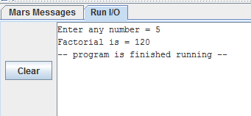

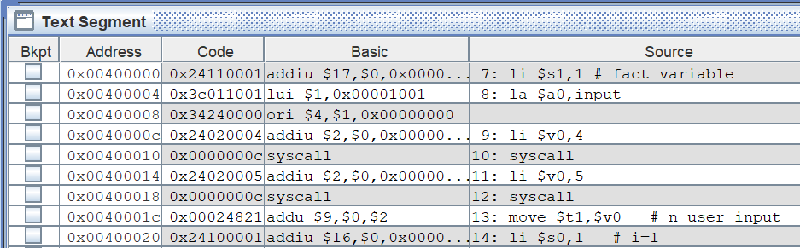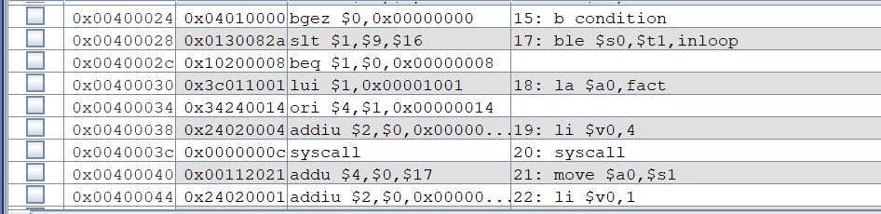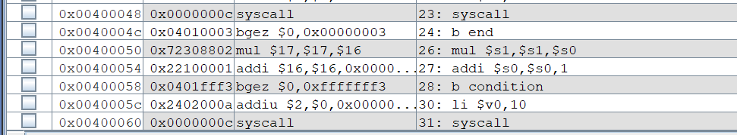

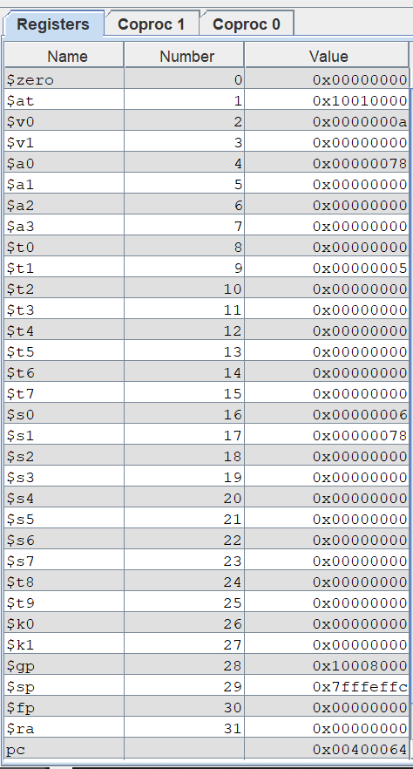

**Task 3 : Adding all numbers from 1 to 10 number using loop.**

**Solution :**

.text

.globl main

main:

li $t0,10

li $a0,0

loop:

add $a0,$a0,$t0

sub $t0,$t0,1

bgez $t0,loop

li $v0,1

syscall

li $v0,10

syscall

**Output :**

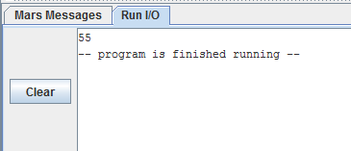

**Task 4 : Write a program in MIPS assembly language that provide the sum from 1 to 99 using for Loop.**

**Solution :**

.data

space: .asciiz " + "

line: .asciiz "\n"

equal: .asciiz " = "

.text

li $s0,10

li $t0,0

li $t1,100

li $s1,0 #sum variable

.globl main

main:

addi $t0,$t0,1

add $s1,$t0,$s1

ble $t0,$s0,print

la $a0,line

li $v0,4

syscall

addi $s0,$s0,10

b print

print:

move $a0,$t0

li $v0,1

syscall

bge $t0,$t1,end

la $a0,space

li $v0,4

syscall

b main

end:

la $a0,equal

li $v0,4

**Output :**

